**SYLLABUS**

**SCILAB & Python Algorithm of:**

* **Interpolation**

1. Newton Forward Method

2. Newton Backward Method

3. Langrange's Method

* **Solution of linear Equations**

4. Gauss-Elimination/Gauss Jordan Method

5. Gauss Jacobi/Gauss Siedel method

* **Solution of Non-linear Equation**

6. Bisection Method/Secant Method/Regula Falsi Method

7. Newton Raphson Method

* **Solution of Ordinary Differential Equations (1st order, Initial Value Problem)**

8. Eulers method

9. Modified Eulers Method

10. Runge-Kutta Method

* **Solution of Ordinary Differential Equations (2nd order, Boundary Value Problem)**

11. Finite Difference Method

* **Solution of Partial Differential Equations**

12. Bender Schmidt Method

**Notes for MID-SEM**

**Solution of Ordinary Differential Equations (ODE), First Order-Initial Value Problem (IVP)**

**Scilab**

*//Algorithm to compare the results of ODE function and Eulers results*

clc; clear;clf()

k = 0.05; CA0 = 1.0; t0 = 0; tf = 100; h = 5;

function **dC**=f(**t**, **C**)

**dC** = -k * **C**^2

endfunction

t = t0:h:tf

n = length(t)-1

t_euler = zeros(1,n+1)

CA_euler = zeros(1,n+1)

t_euler(1) = t0

CA_euler(1) = CA0

for i = 1:n

t_euler(i+1) = t_euler(i) + h

CA_euler(i+1) = CA_euler(i) + h * f(t_euler(i), CA_euler(i))

end

C_num = ode(CA0, t0, t, f)

scf(0)

plot(t, C_num, 'r-', 'LineWidth', 2)

plot(t, CA_euler, 'b--', 'LineWidth', 2)

xlabel("Time (s)")

ylabel("Concentration C_A (mol/L)")

title("Second-order Batch Reactor: Numerical vs Analytical Solution")

legend("Numerical (ODE solver)", "Euler Method")

xgrid()

*//Algorithm to solve the Eulers method, Modified Eulers Method, RK-4 Method*

clc; clear;clf()

k=0.05

function **dCa**=f(**t**, **Ca**)

**dCa** = -k * **Ca**^2

endfunction

t0 = 0; Ca0 = 1; tf = 100; h = 5

n = (tf - t0) / h

*//Eulers method*

t_euler = t0

Ca_euler = Ca0

for i = 1:n

t_euler(i+1) = t_euler(i) + h

Ca_euler(i+1) = Ca_euler(i) + h * f(t_euler(i), Ca_euler(i))

end

*//Modified Eulers method*

t_mod_euler = t0

Ca_mod_euler = Ca0

for i = 1:n

t_mod_euler(i+1) = t_mod_euler(i) + h

Ca_pred = Ca_mod_euler(i) + h * f(t_mod_euler(i), Ca_mod_euler(i))

Ca_mod_euler(i+1) = Ca_mod_euler(i) + (h/2) * (f(t_mod_euler(i), Ca_mod_euler(i)) + f(t_mod_euler(i+1), Ca_pred))

end

*//RK-4 Method*

t_rk4 = t0

Ca_rk4 = Ca0

for i = 1:n

k1 = h * f(t_rk4(i), Ca_rk4(i))

k2 = h * f(t_rk4(i) + h/2, Ca_rk4(i) + k1/2)

k3 = h * f(t_rk4(i) + h/2, Ca_rk4(i) + k2/2)

k4 = h * f(t_rk4(i) + h, Ca_rk4(i) + k3)

Ca_rk4(i+1) = Ca_rk4(i) + (k1 + 2*k2 + 2*k3 + k4) / 6

t_rk4(i+1) = t_rk4(i) + h

end

plot(t_euler, Ca_euler, '-ob')

plot(t_mod_euler, Ca_mod_euler, '-sg')

plot(t_rk4, Ca_rk4, '-^r')

xlabel("x")

ylabel("y")

title("Comparison of Methods")

legend(["Euler", "Modified Euler", "RK-4"])

xgrid()

**Python**

#Algorithm to compare the results of ODE function and Eulers results

import numpy as np

import matplotlib.pyplot as plt

from scipy.integrate import odeint

k = 0.05; CA0 = 1.0; t0 = 0; tf = 100; h = 5;

def f(C, t):

return -k * C**2

t = np.arange(t0, tf + h, h)

n = len(t) - 1

CA_euler = np.zeros(n+1)

CA_euler[0] = CA0

for i in range(n):

CA_euler[i+1] = CA_euler[i] + h * f(CA_euler[i], t[i])

C_num = odeint(f, CA0, t).flatten()

plt.figure(figsize=(8,6))

plt.plot(t, C_num, 'r-', linewidth=2, label="Numerical (ODE solver)")

plt.plot(t, CA_euler, 'b--', linewidth=2, label="Euler Method")

plt.xlim(0,100)

plt.ylim(0,1)

plt.xlabel("Time (s)")

plt.ylabel("Concentration C_A (mol/L)")

plt.title("Second-order Batch Reactor: Numerical vs Euler Solution")

plt.legend()

plt.grid(True)

plt.show()

#Comparison of Results of Eulers method, Modified Eulers Method & RK-4 Method

import numpy as np

import matplotlib.pyplot as plt

k = 0.05

def f(t, Ca):

return -k * Ca**2

t0 = 0; Ca0 = 1; tf = 100; h = 5

n = int((tf - t0) / h)

t_euler = np.zeros(n+1)

Ca_euler = np.zeros(n+1)

t_euler[0], Ca_euler[0] = t0, Ca0

for i in range(n):

t_euler[i+1] = t_euler[i] + h

Ca_euler[i+1] = Ca_euler[i] + h * f(t_euler[i], Ca_euler[i])

t_mod_euler = np.zeros(n+1)

Ca_mod_euler = np.zeros(n+1)

t_mod_euler[0], Ca_mod_euler[0] = t0, Ca0

for i in range(n):

t_mod_euler[i+1] = t_mod_euler[i] + h

Ca_pred = Ca_mod_euler[i] + h * f(t_mod_euler[i], Ca_mod_euler[i])

Ca_mod_euler[i+1] = Ca_mod_euler[i] + (h/2) * (f(t_mod_euler[i], Ca_mod_euler[i]) + f(t_mod_euler[i+1], Ca_pred))

t_rk4 = np.zeros(n+1)

Ca_rk4 = np.zeros(n+1)

t_rk4[0], Ca_rk4[0] = t0, Ca0

for i in range(n):

k1 = h * f(t_rk4[i], Ca_rk4[i])

k2 = h * f(t_rk4[i] + h/2, Ca_rk4[i] + k1/2)

k3 = h * f(t_rk4[i] + h/2, Ca_rk4[i] + k2/2)

k4 = h * f(t_rk4[i] + h, Ca_rk4[i] + k3)

Ca_rk4[i+1] = Ca_rk4[i] + (k1 + 2*k2 + 2*k3 + k4) / 6

t_rk4[i+1] = t_rk4[i] + h

plt.figure(figsize=(8,6))

plt.plot(t_euler, Ca_euler, '-ob', label="Euler")

plt.plot(t_mod_euler, Ca_mod_euler, '-sg', label="Modified Euler")

plt.plot(t_rk4, Ca_rk4, '-^r', label="RK-4")

plt.xlabel("Time (s)")

plt.ylabel("Concentration C_A (mol/L)")

plt.title("Comparison of Methods for 2nd-order Batch Reactor")

plt.legend()

plt.grid(True)

plt.show()

**Solution of Ordinary Differential Equations (ODE), 2nd Order-Boundary Value Problem (BVP)**

Q. $\frac{d^{2}y}{dx^{2}}=8x\left(9-x\right)+2y$ BC-I: $y_{(X=0)}=0$ BC-II $y_{(X=9)}=0$

*//Algorithm for Finite Difference Method*

clc; clear; clf();

x0 = 0; xn = 9; y0 = 0; yn = 0

h = 0.1

x = x0:h:xn

n=(xn-x0)/h

A = zeros(n-1, n-1)

B = zeros(n-1, 1)

for i = 1:n-1

p = 0; q = -2; r = 8*x(i+1)*(9-x(i+1))

a = (1/h^2) - (p/(2*h))

b = -(2/h^2) + q

c = (1/h^2) + (p/(2*h))

d = r

if i > 1 then

A(i, i-1) = a

end

A(i, i) = b

if i < n-1 then

A(i, i+1) = c

end

B(i) = d

end

Y_internal = A \ B

Y = [y0; Y_internal; yn]

disp(A,B)

disp('x values:'), disp(x)

disp('y values:'), disp(Y)

plot(x, Y, '-o')

xlabel('x')

ylabel('y')

title('Finite Difference Method Solution')

**Python**

# Finite Difference Method

import numpy as np

import matplotlib.pyplot as plt

x0 = 0; xn = 9; y0 = 0; yn = 0

h = 1

x = np.arange(x0, xn + h, h)

n = int((xn - x0) / h)

A = np.zeros((n-1, n-1))

B = np.zeros((n-1, 1))

for i in range(n-1):

xi = x[i+1]

p = 0

q = -2

r = 8 * xi * (9 - xi)

a = (1/h**2) - (p/(2*h))

b = -(2/h**2) + q

c = (1/h**2) + (p/(2*h))

d =r

if i > 0:

A[i, i-1] = a

A[i, i] = b

if i < n-2:

A[i, i+1] = c

B[i] = d

Y_internal = np.linalg.solve(A, B)

Y = np.vstack(([y0], Y_internal, [yn]))

print('x values:')

print(x)

print('y values:')

print(Y.flatten())

plt.plot(x, Y, 'o-', label="Finite Difference Solution")

plt.xlabel('x')

plt.ylabel('y')

plt.title('Finite Difference Method Solution')

plt.grid(True)

plt.legend()

plt.show()

**15. Solution of Partial Differential Equations (PDE)**

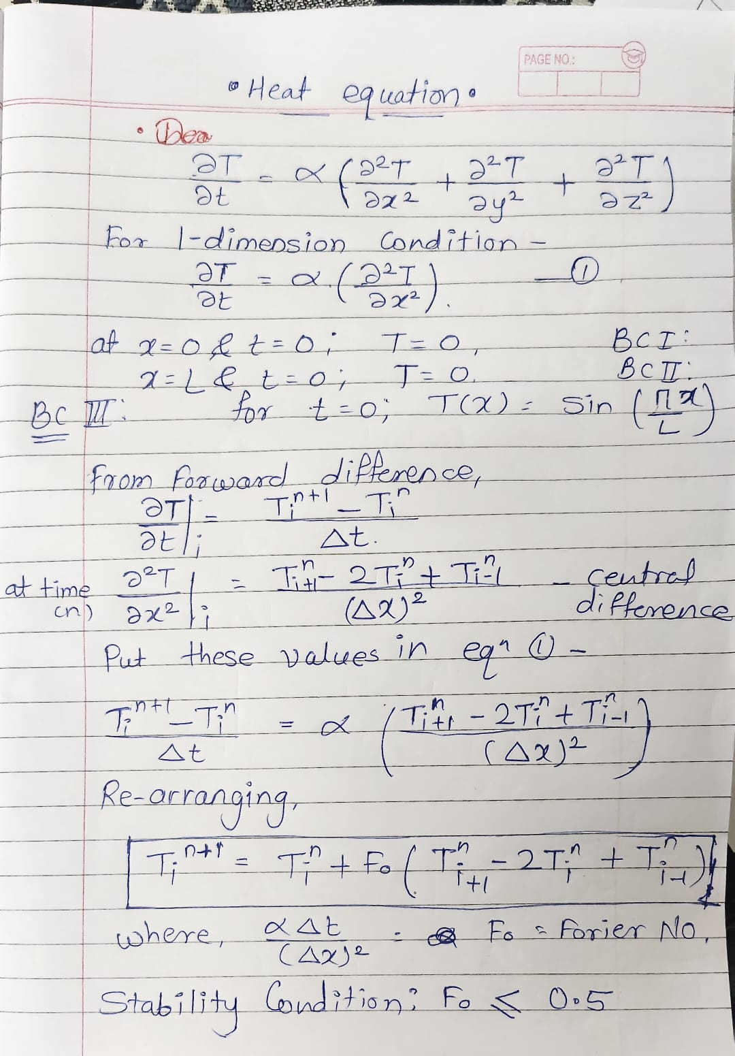

**Scilab**

*//Algorithm for solution of 1D Heat Equation by bender Schmidt Method*

clc; clear; clf();

L = 1; nx = 20; dx = L/(nx-1)

alpha = 0.01; dt = 0.0005; nt = 200

Fo = alpha*dt/(dx^2)

if Fo > 0.5 then

error("Warning: Scheme unstable. Reduce dt or increase nx.")

end

x = linspace(0, L, nx)

time = 0:dt:nt*dt

T = exp(-200*(x-0.5).^2)

T(1) = 0; T($) = 0

Tsol = zeros(nt+1, nx)

Tsol(1,:) = T

for t = 1:nt

Told = T

for i = 2:nx-1

T(i) = Told(i) + Fo*(Told(i+1) - 2*Told(i) + Told(i-1))

end

Tsol(t+1,:) = T

end

clf()

surf(x, time, Tsol)

xlabel("Rod length x (m)")

ylabel("Time (s)")

zlabel("Temperature")

xtitle("Transient 1D Heat Conduction (Explicit FD)")

*//Algorithm for 2D heat Equation by Bender Schmidt Method*

clc; clear; clf();

Lx = 0.1; Ly = 0.1

nx = 21; ny = 21

dx = Lx/(nx-1); dy = Ly/(ny-1)

alpha = 0.01; dt=0.0001; tf = 1000

Fox = alpha*dt/(dx^2)

Foy = alpha*dt/(dy^2)

if Fox + Foy > 0.5 then

error("Unstable scheme! Reduce dt or refine grid.")

end

x = linspace(0, Lx, nx)

y = linspace(0, Ly, ny)

[X,Y] = ndgrid(x,y);

T = exp(-5*((X-0.5).^2 + (Y-0.5).^2))

T(1,:) = 0; T($,:) = 0

T(:,1) = 0; T(:,$) = 0

zmax = max(T(:))

for t = 1:tf

Told = T

for i = 2:nx-1

for j = 2:ny-1

T(i,j) = Told(i,j) + ...

Fox*(Told(i+1,j) - 2*Told(i,j) + Told(i-1,j)) + ...

Foy*(Told(i,j+1) - 2*Told(i,j) + Told(i,j-1))

end

end

if modulo(t,20)==0 then

clf()

surf(x,y,T')

xlabel("x"); ylabel("y"); zlabel("Temperature")

colorbar()

a = gca()

a.data_bounds = [0,0,0; Lx,Ly,zmax]

xtitle(msprintf("2D Heat Conduction at time step %d", t))

sleep(200)

end

end

**Python**

#Algorithm for 1D Heat Equation by Bender Schmidt Method

import numpy as np

import matplotlib.pyplot as plt

L = 1.0; nx = 20; dx = L / (nx - 1); alpha = 0.01

dt = 0.0005; nt = 200

Fo = alpha * dt / (dx**2)

if Fo > 0.5:

print("Warning: Scheme unstable. Reduce dt or increase nx.")

x = np.linspace(0, L, nx)

T = np.sin(np.pi * x / L)

T[0] = 0.0; T[-1] = 0.0

plt.ion()

fig, ax = plt.subplots()

for t in range(1, nt + 1):

Told = T.copy()

for i in range(1, nx - 1):

T[i] = Told[i] + Fo * (Told[i+1] - 2*Told[i] + Told[i-1])

if t % 20 == 0:

ax.clear()

ax.plot(x, T, '-o')

ax.set_title(f"1D Heat Conduction (Explicit FD)\nTime step {t}")

ax.set_xlabel("x (rod length)")

ax.set_ylabel("Temperature")

ax.set_ylim(0, 1)

plt.pause(0.1)

plt.ioff()

plt.show()